Noise – Near Real Time data exchange
Peter Kjeld (SES5)

Date | Version | Comment
25-02-2011 | 0.8 | Initial version, Peter Kjeld

Summary
This document describes how near real time (NRT) noise data can be exchanged and shared between different organisations. Based on experience from the EEA NRT ozone data exchange system we have decided to use an existing standard for the data exchange instead of inventing a new data format.

The system is based on the Open GIS Consortium (OGC) Sensor Observation Service (SOS). SOS is very useful for exchanging NRT data exchange and behind the scenes SOS is using another OGC standard; Observation and Measurement (O&M) encoding standard. The use of SOS and O&M gives a very strong and future proof platform.

Architecture
Figure 1 shows an example of three different networks measuring noise which all delivers noise data to EEA. Be aware that this is a thought of example and the system was not in place when this document was written.

For instance, the Irish EPA collects noise data from a number of observation stations and collects them on a national or regional server. This server then produces a datafile, here called OM XML, which is transferred to the EEA NRT platform. The OM XML can be transferred using different protocols, the simplest one being FTP where the OM XML file is put on a FTP account from where EEA NRT platform can pick it up. Another option would be a HTTP download, HTTP post or uses a webservice to exchange the file. Which transport mechanism to use depends on the setup at each dataprovider, and the possibilities available.

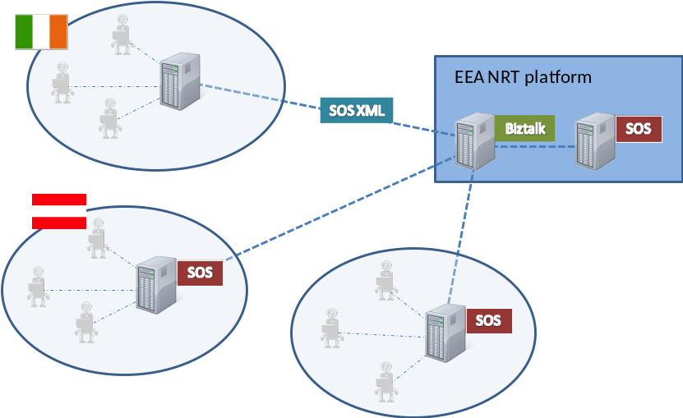

Figure 1: Networks delivering noise data to EEA

The Irish example is the simplest; here we have just defined the data format which should be used in the data exchange and how the file is exchanged (which protocol to use). So the Irish dataprovider will have to create a script which can extract and export the data into the specified data format. This scenario requires a software developer which in a couple of days can develop the script to extract the data into the OM XML data file (described later in the document).

A more sophisticated scenario is for the Austrian example. Here Austria has setup a national (or regional) SOS node where noise data is collected and can be queried and accessed by an external organisation like EEA. The EEA NRT platform will then query the Austrian SOS directly (through a http request) and based on the defined query make sure that the Austrian noise data is mirrored to the EEA NRT Noise database.

In both scenarios the data exchange is based on OM XML files.

XML Schema and data format
O&M provides extensive functionality but in order to keep it simple, we have in the sample below shown how the noise level can be described in O&M at two different locations. The two locations have the identifiers IE10001 and IE10002 which is two fictive locations.

The main structure of the OM XML is (… indicates one or more levels has been omitted).
- om:ObservationCollection
  - om:member – one section for each location (IE10001 and IE10002)
    - om:Observation
      - om:samplingTime …
      - om:procedure
      - om:observedProperty
      - om:featureOfInterest …
      - om:result
        - swe:dataArray
          - swe:elementCount …
          - swe:elementType …
          - swe:encoding …
          - swe:values

<?xml version="1.0" encoding="utf-8"?>
<!-- a series of om:member element which each contain one measurement -->
<om:ObservationCollection xmlns:om="http://www.opengis.net/om/1.0"
xmlns:gml="http://www.opengis.net/gml"
xmlns:xlink="http://www.w3.org/1999/xlink"
xmlns:sa="http://www.opengis.net/sampling/1.0"
xmlns:swe="http://www.opengis.net/swe/1.0.1">

<om:member>
<om:Observation>
<!-- time period for which this O&M document contains observations - temporal extent -->
<om:samplingTime>
<gml:TimePeriod>
<gml:beginPosition>2010-06-02T00:00:00.000+2:00</gml:beginPosition>
<gml:endPosition>2010-06-02T09:00:00.000+2:00</gml:endPosition>
</gml:TimePeriod>
</om:samplingTime>

<!-- identifiers of the sensors that have created the observations contained in this document -->
<om:procedure xlink:href="IE10001"/>

<!-- description of the observed phenomenon -->
<om:observedProperty xlink:href="Noiselevel"/>

<!-- description of the sensor that generated the observations -->
<om:featureOfInterest>
<gml:FeatureCollection>
<gml:featureMember>
<sa:SamplingPoint>
<gml:name>Smithfield</gml:name>
<sa:position>
<gml:point srsName="urn:ogc:def:crs:EPSG:4326">
<gml:pos>53.348809 -6.270446</gml:pos>
</gml:point>
</sa:position>
</sa:SamplingPoint>
</gml:featureMember>
</gml:FeatureCollection>
</om:featureOfInterest>

<!-- the observation data are encoding into a compact form -->
<om:result>
<swe:DataArray>
<swe:elementCount>
<swe:Count>
<swe:value>9</swe:value>
</swe:Count>
</swe:elementCount>
<swe:elementType name="Components">
<swe:SimpleDataRecord>
<swe:field name="begintime">
<swe:Time definition="begintime:8601"/>
</swe:field>
<swe:field name="endtime">
<swe:Time definition="endtime:8601"/>
</swe:field>
<swe:field name="feature">
<swe:Text definition="urn:ogc:data:feature"/>
</swe:field>
<swe:field name="noise">
<swe:Quantity definition="noiselevel">
<swe:uom definition="db"/>
</swe:Quantity>
</swe:field>
</swe:SimpleDataRecord>
</swe:elementType>

<swe:encoding>
<swe:TextBlock decimalSeparator="." tokenSeparator="," blockSeparator=";"/>
</swe:encoding>

<swe:values>
2010-06-02T00:00:00.000+2:00,2010-06-02T01:00:00.000+2:00,IE10001,43.0;
2010-06-02T01:00:00.000+2:00,2010-06-02T02:00:00.000+2:00,IE10001,40.0;
2010-06-02T02:00:00.000+2:00,2010-06-02T03:00:00.000+2:00,IE10001,38.0;
2010-06-02T03:00:00.000+2:00,2010-06-02T04:00:00.000+2:00,IE10001,41.0;
2010-06-02T04:00:00.000+2:00,2010-06-02T05:00:00.000+2:00,IE10001,44.0;
2010-06-02T05:00:00.000+2:00,2010-06-02T06:00:00.000+2:00,IE10001,48.0;
2010-06-02T06:00:00.000+2:00,2010-06-02T07:00:00.000+2:00,IE10001,50.0;
2010-06-02T07:00:00.000+2:00,2010-06-02T08:00:00.000+2:00,IE10001,52.0;
2010-06-02T08:00:00.000+2:00,2010-06-02T09:00:00.000+2:00,IE10001,55.0;
</swe:values>

</swe:DataArray>
</om:result>

</om:Observation>
</om:member>

<om:member>
<om:Observation>
<!-- time period for which this O&M document contains observations - temporal extent -->
<om:samplingTime>
<gml:TimePeriod>
<gml:beginPosition>2010-06-02T00:00:00.000+2:00</gml:beginPosition>
<gml:endPosition>2010-06-02T09:00:00.000+2:00</gml:endPosition>
</gml:TimePeriod>
</om:samplingTime>

<!-- identifiers of the sensors that have created the observations contained in this document -->
<om:procedure xlink:href="IE10002"/>

<!-- description of the observed phenomenon -->
<om:observedProperty xlink:href="Noiselevel"/>

<!-- description of the sensor that generated the observations -->
<om:featureOfInterest>
<gml:FeatureCollection>
<gml:featureMember>
<sa:SamplingPoint>
<gml:name>Bridge Street</gml:name>
<sa:position>
<gml:point srsName="urn:ogc:def:crs:EPSG:4326">
<gml:pos>53.341494 -6.228990</gml:pos>
</gml:point>
</sa:position>
</sa:SamplingPoint>
</gml:featureMember>

</gml:FeatureCollection>

</om:featureOfInterest>

<!-- the observation data are encoding into a compact form -->
<om:result>
<swe:DataArray>
<swe:elementCount>
<swe:Count>
<swe:value>9</swe:value>
</swe:Count>
</swe:elementCount>
<swe:elementType name="Components">
<swe:SimpleDataRecord>
<swe:field name="begintime">
<swe:Time definition="begintime:8601"/>
</swe:field>
<swe:field name="endtime">
<swe:Time definition="endtime:8601"/>
</swe:field>
<swe:field name="feature">
<swe:Text definition="urn:ogc:data:feature"/>
</swe:field>
<swe:field name="noiselevel">
<swe:Quantity definition="noiselevel">
<swe:uom definition="db"/>
</swe:Quantity>
</swe:field>
</swe:SimpleDataRecord>
</swe:elementType>

<swe:encoding>
<swe:TextBlock decimalSeparator="." tokenSeparator="," blockSeparator=";"/>
</swe:encoding>

<swe:values>
2010-06-02T00:00:00.000+2:00,2010-06-02T01:00:00.000+2:00,IE10002,53.0;
2010-06-02T01:00:00.000+2:00,2010-06-02T02:00:00.000+2:00,IE10002,50.0;
2010-06-02T02:00:00.000+2:00,2010-06-02T03:00:00.000+2:00,IE10002,58.0;
2010-06-02T03:00:00.000+2:00,2010-06-02T04:00:00.000+2:00,IE10002,51.0;
2010-06-02T04:00:00.000+2:00,2010-06-02T05:00:00.000+2:00,IE10002,54.0;
2010-06-02T05:00:00.000+2:00,2010-06-02T06:00:00.000+2:00,IE10002,58.0;
2010-06-02T06:00:00.000+2:00,2010-06-02T07:00:00.000+2:00,IE10002,60.0;
2010-06-02T07:00:00.000+2:00,2010-06-02T08:00:00.000+2:00,IE10002,62.0;
2010-06-02T08:00:00.000+2:00,2010-06-02T09:00:00.000+2:00,IE10002,65.0;
</swe:values>

</swe:DataArray>
</om:result>

</om:Observation>
</om:member>
</om:ObservationCollection>
XML 1: Observation collection

Date/time: All date/time are given using ISO8601.

In the suggested XML we have taken benefit of the compact structure for providing measurement values within Sensor Web Enablement (SWE). The same document can also be provided without the use of ‘comma-separation’ in the swe:values tag, but this will make the document size become quite big as we end up with one om:member section per measurement value.

How to prepare the OM XML
If a SOS server is available, the OM XML given in XML 1 can be quite easily created as the request would be something like below – depending on how the SOS has been setup:

<?xml version="1.0" encoding="UTF-8"?>
<GetObservation xmlns="http://www.opengis.net/sos/1.0"
xmlns:ows="http://www.opengis.net/ows/1.1"
xmlns:gml="http://www.opengis.net/gml"
xmlns:ogc="http://www.opengis.net/ogc"
xmlns:om="http://www.opengis.net/om/1.0"
xmlns:xsi="http://www.w3.org/2001/XMLSchema-instance"
xsi:schemaLocation="http://www.opengis.net/sos/1.0 http://schemas.opengis.net/sos/1.0.0/sosGetObservation.xsd"
service="SOS" version="1.0.0" srsName="urn:ogc:def:crs:EPSG:4326">

<offering>Noise</offering>
<procedure>IE10001</procedure>
<procedure>IE10002</procedure>

<observedProperty>Noise</observedProperty>
<responseFormat>text/xml;subtype=&quot;om/1.0.0&quot;</responseFormat>
<resultModel>om:Observation</resultModel>

</GetObservation>
XML 2: GetObservation request

As it is not expected all data providers has a SOS server available, the OM XML can also be generated from a python script or similar. To do this, take another look at XML 1: Since the structure does not change, the focus should be on the text in black.

When preparing the data, one should have in mind that the OM XML requires one om:member section for each measurement location/station, so if 6 measurements stations are available there should be 6 om:member sections.

Annex 1
The complete O&M schema is available at:
http://schemas.opengis.net/om/

